Week 1:
Spend Less Than You Earn

Key phrase: Every spending decision is a spiritual decision.
Scripture: Philippians 4:11-13
VIDEO link: https://12stone.com/watch/master-your-money/spend-less-than-you-earn/

- Introduction
  - Does my money master me or do I master my money?
    - This is where the pressure comes
  - Introduce Video 1 and Ron Blue
    - VIDEO 1 – Introduction of who Ron is – why is he an expert?
      - God’s principles work
      - Ron Blue short bio:
        - Founder of Ronald Blue & Co. manages billions of dollars
        - Founder of Kingdom Advisors
        - Author of more than 20 books
        - Same guy who threatened to leave his wife if she flaunted that Jesus stuff in his face
        - Dave Ramsey said of him, “Long before I was encouraging people to live like no one else, Ron Blue was out blazing new trails as one of the great pioneers of Christian stewardship.”
- Five stages of financial journeys
  - Lead into VIDEO 2 where Ron introduces the five stages of financial journeys
  - Struggling, Surviving, Stable, Secure, Surplus
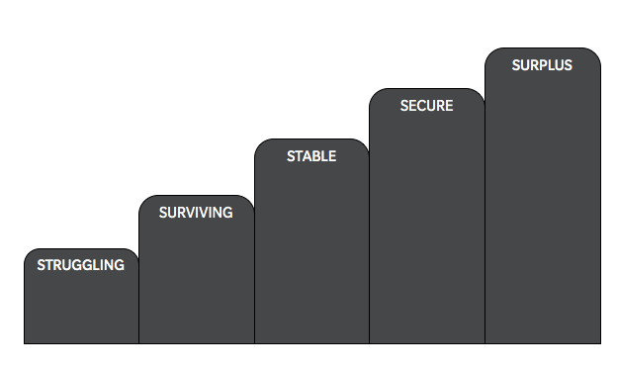
    - Where are you on the journey?
      - Usually looking to move from one stage to the next – when you are at struggling you want to move to surviving and then to stable, etc.
        - Caveat – the goal is not necessarily to reach the surplus or even secure step
        - When Struggling we are not able to make ends meet; when Surviving we are living pay-check to pay-check; when Stable we are able to save some with an emergency fund; when Secure we are able save for long term goals; and with Surplus we have more than enough
      - Ask yourself where am I and how do I get to the next step – answer comes in five biblical principles
        - Introduce VIDEO 3 where Ron shares five fundamental biblical financial principles
        - These five principles help you get to your next step
          - Spend less than you earn
          - Avoid the use of debt
          - Build margin (save)
          - Set long term goals
          - Give generously
- Spend less than you earn
  - You have to make this decision and then battle to make it happen
  - This principle is the foundation to financial strength and the reason people often get in trouble
  - If you don’t buy into this, what is your only alternative spend MORE than you earn
    - PERSONAL ILLUSTRATION: tell a personal story when you gave in to peer pressure to do something you weren’t qualified or prepared to do
      - Examples: leading a white-water rafting trip when you have never rafted before; sky diving without proper training; trying to jump across a raging river
      - When you, under peer pressure, go beyond your limits, you will nearly drown yourself
  - Most people try to attack this principle by focusing on earning more – they think the problem is they are not earning enough
    - What do the following all have in common (bankruptcy):
      - Rapper - 50 Cent
      - Don Johnson
      - MC Hammer
      - Willie Nelson
      - Elton John
      - Stephen Baldwin
      - Kim Basinger
      - Mickey Rooney
      - Meatloaf
      - Dion Warwick
    - These people made a lot of money, but they never solved the first issue of spending less – earning more is not the first thing to solve
  - Ecclesiastes 5:10
    - If you never solve the spend less, then earning more won’t fix it
    - Master Your Money page 14:
      - “One of the dramatic exceptions is that of a retired pastor who never earned more than $8,000 in one year. I met this humble man because he wanted to know if he had enough financial resources to live out the rest of his life. At the time of this question, he was 80 years old; he had been retired for 20 years; and his wife had just begun to require full-time nursing care. His question, therefore, was a justifiable one! As I generally do, I began to ask some questions before giving advice. First, I asked him if he had any debts. His response was no, and he went on to say he had never borrowed any money. I asked, “why not?” He said because if he borrowed money, he would have to pay it back someday, and he couldn’t afford to pay off debt, feed his family, and tithe. My second question was to ask what resources he presently had.”
      - The problem is usually not earning, it is managing it
  - Show VIDEO 4 where Ron talks about the spirituality of all our spending decisions
    - “Every spending decision is a spiritual decision”
      - We tend to live in a reality that God has a portion of this, and then I get to do what I want with the rest of it
      - Maybe our personal finances are in trouble, because while we have the name of Jesus on our lips we have the values of this world in our finances
        - Maybe this is what is wrong in our finances
        - It would be like we prayed for God to heal us from sickness, but then went and drank gasoline all week
          - We must be willing to change our behavior – we must be willing to spend less than we earn
  - Show VIDEO 5 where Ron addresses the question of why is this so hard to do?
    - In a world that is all about more, we are trying to learn to spend less
    - The point is to come and live differently than the world and not look just like the world
  - We all must learn to be content – Phil 4:11-13
    - No matter where you are on the financial journey, you have to learn to be content in that circumstance
    - How do I live content without being complacent or discontent?
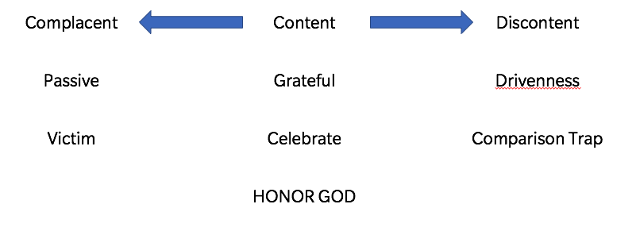
      - To live content I must learn:
        - Grateful
          - Without this, I can enter into drivenness and become discontent or become passive and complacent
        - Celebrate – I must be able to celebrate others when they are blessed
          - Without this, we get caught in a comparison trap and begin to compete with everyone else
            - On the other side, I view myself as a victim and think that nobody else should have this
        - Honor God (follow His principles)
          - Without these, we dishonor His principles
      - Before you can master your money, you must master your emotions
        - Proverbs 21:20
  - What is your choice going to be?
    - Where do you want to be?
- Conclusion: Wondering where to start – how do you get a handle on your spending?
  - Come on back next week and we will dive in

