**Final Financial Plan Project**

**Name: _____________________**

**Week 1: Introduction**

1. This week visit the Core Convictions Chart at the end of the project and list your personal convictions in each area – live, give, owe debt, owe taxes, and grow. This reflection is an expression of how you currently believe and behave as it relates to each broad-based area of spending. For example, a personal conviction regarding how you spend your money to save might be, “I believe that it is responsible to save every month for retirement.”
2. Describe two of your pre-course financial goals or areas of struggle. Be specific as you imagine what it would look like to have clarity and or hope in these areas as a result of your work in this course.

Describe goal/struggle #1 - What would clarity/hope look like here?

|  |
| --- |
|  |
|  |
|  |
|  |
|  |
|  |
|  |

Describe goal/struggle #2 - What would clarity/hope look like here?

|  |
| --- |
|  |
|  |
|  |
|  |
|  |
|  |
|  |

**Week 3: Health and Habits**

**Live, Give, Owe, Grow Pie Dream:**

Envision an ideal future pie for you, imagining that you are ten years in the future and that you have been able to re-balance your spending to reflect your priorities. in ten years based on your proposed career choice and income. What are three priorities now that will have an impact on your pie later?

Time Period: (year, month) _____________________

1. What is your income? *Income*: ________________

2. How much do you give? *Give:* __________________

3. How much do you pay toward debt? *Owe (debt):* ____________

4. How much do you pay in taxes? *Owe (taxes):* ___________

5. How much do you save? *Grow:* _________________

6. Subtract 2-5 from Income to calculate Live *Live*: ___________________

*To calculate what percentage of your income is used for each piece of the pie, divide each category by your income (for example, $10 of Give / $100 of income = 10 percent). Now calculate your future numbers and fill in your pie.*

Give percentage: _______________

Owe-Debt percentage: __________

Owe-Taxes percentage: _________

Grow percentage: _____________

Live percentage: ______________

**Habits Reflections:**

What are your current strengths and weaknesses in your financial habits? Which one comes most easily to you and which one is the hardest? What measurable, actionable steps could you take to grow in the area of weakness in the coming three months?

|  |
| --- |
|  |
|  |
|  |
|  |
|  |
|  |
|  |
|  |
|  |
|  |
|  |

**Weeks 4 - 6: Financial Plan**

A “financial plan” is simply a collection of action steps that someone wants to take regarding their finances in the coming period of time based on their goals. These steps become their roadmap for the future.

By having a financial plan, people can both see their current reality and envision where they are headed, thereby diminishing fear while building hope and confidence. Two key components for sticking with a financial plan are (1) developing good habits and (2) establishing where you are heading.

The **HABITS** below provide some general guidelines that are helpful for everyone. The **HOPE** goal setting process below helps with defining specific goals. This guide will use both **HABITS** and **HOPE** to help you create a basic financial plan and stick with it.

To start, let’s review the **HABITS**:

1. Spend less than you earn
2. Avoid the use of debt
3. Give generously
4. Plan for financial margin (This is where financial **HOPE** becomes a possibility!)
5. Set long-term goals (This is where financial **HOPE** becomes reality!)

Taking action on each of the **HABITS** reveals your current situation and helps you think about the right financial plan for you.

**ACTION STEP #1: Spend Less than You Earn**

*How much do you currently earn or receive from any source, including gifts, allowance, and loans?*

*What are your current expenses?*

*Is your income more than your expenses?*

Is your income more than your expenses? If so, congratulations! If not, accomplishing this Action Step is first priority for you! Either way, before you can make a plan, you will want to create a budget.

**TAKE ACTION: BUDGET**

Remember that a budget is just a plan for where your money will go, and it begins by seeing where your money already is going. Watch Michael’s budgeting video <https://vimeo.com/289949126/bb29e5d251> and apply it to your situation by putting pencil to paper in the exercise below. Then transfer your new budget to an accessible app (such as your online banking app or MINT) to easily track your progress.

**Budget Step 1: Know Your Numbers**

First, examine your spending last month using your online banking and credit card apps to record your income and your spending. Also think back over the last six to nine months and write down unexpected or “lumpy” one-time expenses that you had. At the bottom, note your net positive or negative cash flow.

**Budget Step 2: Categorize your Expenses**

Use simple categories to begin. You might even want to categorize according to the wedges of the pie: Live, Give, Owe Debt, Owe Taxes, Grow, and perhaps you will want to add categories within the Live area such as Housing, Bills, Food, Entertainment, Clothing, Personal Care. Please note, there is a separate Excel worksheet available to you in your course documents that you can use to do a version of this assignment on your computer. For instructions on how to use that worksheet, see this video: <https://vimeo.com/354049062/80b8cf203d>

| Date | Description | Income | Expense | Source (credit, checking, cash) | Type (one-time, weekly, monthly) | Category (choose a few simple ones) |
| --- | --- | --- | --- | --- | --- | --- |
| *5/1* | *Groceries* |  | *$48.75* | *Credit* | *Weekly* | *Live: Food* |
| *5/2* | *Paycheck* | *$134.97* |  | *Checking* | *Bi-weekly* | *Income* |
|  |  |  |  |  |  |  |
|  |  |  |  |  |  |  |
|  |  |  |  |  |  |  |
|  |  |  |  |  |  |  |
|  |  |  |  |  |  |  |
|  |  |  |  |  |  |  |
|  |  |  |  |  |  |  |
|  |  |  |  |  |  |  |
|  |  |  |  |  |  |  |
|  |  |  |  |  |  |  |
|  |  |  |  |  |  |  |
|  |  |  |  |  |  |  |
|  |  |  |  |  |  |  |
|  |  |  |  |  |  |  |
|  |  |  |  |  |  |  |
|  |  |  |  |  |  |  |
|  |  |  |  |  |  |  |
|  |  |  |  |  |  |  |
|  |  |  |  |  |  |  |
|  |  |  |  |  |  |  |
|  |  |  |  |  |  |  |
|  |  |  |  |  |  |  |
|  |  |  |  |  |  |  |
|  |  |  |  |  |  |  |
|  |  |  |  |  |  |  |
|  |  |  |  |  |  |  |
|  |  |  |  |  |  |  |
|  |  |  |  |  |  |  |
|  |  |  |  |  |  |  |
|  |  |  |  |  |  |  |
|  |  |  |  |  |  |  |
|  |  |  |  |  |  |  |
|  |  |  |  |  |  |  |
|  |  |  |  |  |  |  |
|  |  |  |  |  |  |  |
|  |  |  |  |  |  |  |
|  |  |  |  |  |  |  |
|  |  |  |  |  |  |  |
|  |  |  |  |  |  |  |
|  |  |  |  |  |  |  |
|  |  |  |  |  |  |  |
|  |  |  |  |  |  |  |
|  |  |  |  |  |  |  |
|  |  |  |  |  |  |  |
|  |  |  |  |  |  |  |
|  |  |  |  |  |  |  |
|  |  |  |  |  |  |  |
|  |  |  |  |  |  |  |
|  |  |  |  |  |  |  |
|  |  |  |  |  |  |  |
|  |  |  |  |  |  |  |
|  |  |  |  |  |  |  |
|  |  |  |  |  |  |  |
|  |  |  |  |  |  |  |
|  |  |  |  |  |  |  |
|  |  |  |  |  |  |  |
|  |  |  |  |  |  |  |
|  |  |  |  |  |  |  |
|  |  |  |  |  |  |  |
|  |  |  |  |  |  |  |
|  |  |  |  |  |  |  |
|  |  |  |  |  |  |  |
|  |  |  |  |  |  |  |
| TOTAL INCOME | |  | |  |  |  |
| TOTAL SPENDING | |  | |  |  |  |
| POSITIVE OR NEGATIVE CASH FLOW | |  | |  |  |  |

**Budget Step 3: Prioritize your Spending**

Remember that whatever spending category that you prioritize last will get the pressure when money runs low. Biblically speaking, giving and saving are productive, debt and taxes are obligations, and lifestyle spending should get what is left. Using Michael’s teaching, determine the amount available for your living expenses on this chart.

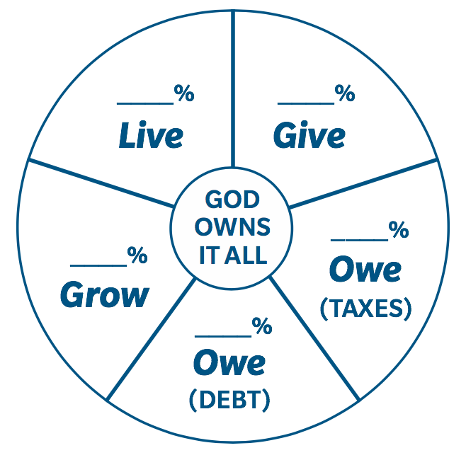

|  |  |
| --- | --- |
| **Income** | $ |
| **Mandatory Expenses** |  |
| Giving | $ |
| Saving | $ |
| Taxes | $ |
| Debt | $ |
| **Total (subtract from Income)** | $ |
| Remaining for Lifestyle | $ |

At this point, you may see a few realities about your finances, perhaps including the following:

* You’d like to give or save more than you currently do.
* Your debt load is severely hindering your spending in other areas.
* Your lifestyle amount seems like it should work, but it rarely covers your expenses.
* You get surprised by taxes and don’t know how to account for them.

Record what you notice about your finances here:

_____________________________________________________________________________

_____________________________________________________________________________

We all have a unique financial picture, but your next ACTION STEP will relate to one of the four remaining **HABITS**!

*One Step Further: Additional Reflection Opportunity (completion NOT required)*

Examine the verses in 1 Timothy (4:4, 5:8, 6:6-10) in light of lifestyle decisions and the biblical exhortation toward provision, contentment, and enjoyment. What do you notice about the context of the verses? How do these verses further inform your understanding of the financial aspects of a Christian lifestyle?

**ACTION STEP #2: Avoid the Use of Debt**

*Do you want to reduce your debt?*

*Debt always mortgages the future.*

*The debt you took on in the past is now cramping your style today, right? Or, new debt you are taking on today will mess with tomorrow’s financial flexibility, and that won’t be very much fun!*

*What can be done?!*

**TAKE ACTION: KNOWLEDGE IS POWER**

**Knowledge Step 1: Know your debt situation**

List the debt you have, the monthly payment, the time remaining to pay it off, and the interest rates on your debt. To find your student debt balance, refer to Appendix A and/or the teaching videos in Week 5.

|  |  |  |  |
| --- | --- | --- | --- |
| Debt Type/Total | Monthly Payment | Time Remaining | Interest Rate |
|  |  |  |  |
|  |  |  |  |
|  |  |  |  |
|  |  |  |  |
|  |  |  |  |
|  |  |  |  |

(If you need help figuring this out, ask a financially minded friend, a parent, or a mentor whose financial life you respect to help you untangle the knot.)

**Knowledge Step 2: Know your next step**

Everyone’s debt situation is unique, but all debt should be repaid. If you decide you want to pay your debt off more quickly than you currently are, experts advise the following:

1. Aggressively work to pay the smallest amount off first.
2. After you’ve completed that debt repayment, roll the same monthly payment from the debt you just paid off toward the next biggest amount of debt and tackle it next.
3. Repeat until you’ve attacked all of your debt.

This system helps you remove complication by eliminating various creditors quickly, allowing you to ultimately focus your funds on the biggest debt you have.

Perhaps your next step is to get advice. Perhaps it is to give up some convenience or luxury item that you regularly purchase and apply it to your debt instead. Perhaps it is to find an accountability partner for your debt. Or maybe it is simply to begin to live within your income so that you stop going into debt.

Record your personal next step here: ­­­____________________________________________

*One Step Further: Additional Reflection Opportunity (completion NOT required)*

Student Loans Reflection Questions:

What type of student loans do you have (subsidized or unsubsidized)?

What is the difference between the two?

How will you determine the amount of debt that you really need?

What is your plan to repay the student debt that you have?

Who can you ask to help hold you accountable for your debt repayment plan (or to help you come up with one if you don’t have one already)?

Credit Card Debt Reflection Questions:

What is your annual interest rate on your credit cards?

What do you typically use your credit card for, and what is your repayment strategy for your credit cards?

Have you ever gone a month without using your credit card? If you did that, what things in your life and in your spending patterns would change?

Ron says that debt is symptomatic of other things. If that’s true, what might your debt be symptomatic of in your life?

**ACTION STEP #3: Give Generously**

*Giving recognizes God’s ownership.*

*Giving breaks the power of money.*

*Giving changes your heart.*

*Giving connects your money to stories God is telling in the world.*

*Giving is an act of obedience, and practicing it blesses the world, blesses God, blesses us, both now and in eternity.*

*So, where do you want your heart to expand?*

**TAKE ACTION: FLEX YOUR HEART MUSCLE**

Giving can be a hard habit to start on a limited budget. As a young person, your money and your time are probably both fairly limited. By leaning into the idea that your time, your money, and your very uniqueness are all gifts to be stewarded, you begin to flex your heart muscle in the direction of God’s good purposes.

Flex your heart muscle by reflecting on the following questions:

What do you have more of – time or money?

|  |
| --- |
|  |
|  |

What else do you have? (relationships, skills, interests, experiences)

|  |
| --- |
|  |
|  |
|  |

Are there places that you’d like your heart to be more connected?

|  |
| --- |
|  |
|  |
|  |

Can you give a combination of what you have to that place in some way?

|  |
| --- |
|  |
|  |
|  |

How much money will you give?

|  |
| --- |
|  |

Where will that money come from?

|  |
| --- |
|  |
|  |
|  |

What else could you give, and what might that look like?

|  |
| --- |
|  |
|  |
|  |

*One Step Further: Additional Reflection Opportunity (completion NOT required)*

Can you think of a significant gift that you have received from someone in your life? What did the gift mean to you at the time? Did it draw you closer to the giver? Now think of a time that you gave something important (time, money, etc.) away. What happened to your heart in that exchange? What did it do for the recipient? How do these reflections reinforce God’s idea that your heart follows your material giving?

**ACTION STEP #4: Plan for Financial Margin**

*How about savings? Would you like to start that habit?*

*You learned that a little bit of savings over a long time goes a LOONNNNG way! The magic of compounding takes time + interest and turns a small habit into a large lump sum.*

*Both giving and saving are easy to overlook, but they are also areas where the power of habit takes hold and makes magic.*

**TAKE ACTION: AUTOMATE**

The best way to save is by figuring out how to get your savings taken out of your account “off the top.” If you can tell your bank to set aside a certain amount each month, after a while you will not even notice that money is gone.

Answer a few questions so that you know what’s right for you:

What are you saving for in the short term?

|  |
| --- |
|  |
|  |
|  |

Are there any longer-term things you’d like to save for? Consider visiting <https://www.investor.gov/additional-resources/free-financial-planning-tools/compound-interest-calculator> to see how much your money might grow over time with compound interest.

|  |
| --- |
|  |
|  |
|  |

How much could you save each month by modifying your lifestyle to give you more margin? What would need to go and what could stay?

|  |
| --- |
|  |
|  |
|  |

What automatic transfers do you plan to establish?

|  |
| --- |
|  |
|  |
|  |

Where else could you consider saving money? (for about a $1,000 initial investment, you can open a mutual fund account with a company like Vanguard)

|  |
| --- |
|  |
|  |
|  |

*One Step Further: Additional Reflection Opportunity (completion NOT required)*

Using the compound interest calculator from above, run various scenarios on interest rates, etc., to see what saving your amount now could mean for your future. What do you notice about the various scenarios? How is this exercise encouraging, motivational, or hopeful?

**ACTION STEP #5: Set Long-Term Goals**

*The longer term your perspective, the better your decision today!*

*All of us can get anxious about tomorrow and confused about today – it’s a human reality to do so. However, setting faith financial goals with God allow you to do two things:*

*To remember His character and care, reducing today’s anxiety.*

*To orient your financial habits toward specific future goals, reducing today’s confusion*.

*Faith goal setting means inviting God into the unknowns of the todays and tomorrows, knowing that our financial lives are a key outworking of our faith lives.*

**TAKE ACTION: INVITE GOD IN**

Re-watch the goal-setting video: <https://vimeo.com/290037910/0fa1e9f2d6>

**Invite Step 1: Discern**

Speak and listen to God. Take time to consider one desire for growth in each wedge of your financial pie (Live, Give, Owe, Grow), asking God to remind you of the ways He has been leading and directing you over this course. You may want to use the Treasure Target and ask God if there is a place on it that He’s inviting you to grow.

**Invite Step 2: Direction**

Write down what you hear God saying and begin to form two goals, stating a specific direction.

|  |
| --- |
|  |
|  |
|  |
|  |
|  |
|  |
|  |
|  |

**Invite Step 3: Detail**

What is the detail of the faith goals you are setting?

Write the goals:

|  |
| --- |
|  |
|  |
|  |
|  |

Rewrite the goals in a measurable way:

|  |
| --- |
|  |
|  |
|  |
|  |

Rewrite the goals in an actionable way:

|  |
| --- |
|  |
|  |
|  |
|  |

Rewrite the goals in a time-bound way:

|  |
| --- |
|  |
|  |
|  |
|  |

Rewrite the goals in a realistic way, or acknowledge a specific faith step that God is leading you to take:

|  |
| --- |
|  |
|  |
|  |
|  |

At this point, go back to your budget and record any necessary adjustments to reflect your goals.

**Invite Step 4: Dynamic**

Stay aware of what God might be shifting over time as it relates to your goals. Perhaps put a reminder on your calendar once per month to pray for 15 minutes, reviewing this goal setting process with the Lord.

**Invite Step 5: Dialogue**

Connecting regularly with someone who can offer wise counsel and accountability along the way. Who might that person be? Can you take the time to call them today to invite them to join you in your journey?

|  |
| --- |
|  |
|  |
|  |

**ACTION STEP #6: Practice Your Plan**

Congratulations! You’ve done the hard work of examining your current financial life and planning for your future! Now what? Consider the following questions to determine how best to implement your plan.

What are your top three takeaways from your plan?

|  |
| --- |
|  |
|  |
|  |
|  |
|  |

What are your top three action steps from your plan?

|  |
| --- |
|  |
|  |
|  |
|  |
|  |
|  |
|  |
|  |
|  |

How do you best implement change? (some ideas include accountability, reminders on your phone, apps to help you track, setting up rewards for certain milestones, keeping your action items visible, etc.)

|  |
| --- |
|  |
|  |
|  |
|  |

What can you do in the next 24 hours to begin to take action?

|  |
| --- |
|  |
|  |
|  |

What can you do in the next week to continue to take action?

|  |
| --- |
|  |
|  |
|  |

What can you do a month from now to remind yourself of the action you’d like to take?

|  |
| --- |
|  |
|  |
|  |

**Week 7: Hope**

Reflect back on all four elements – Heart, Health, Habits, and Hope. Which one was most impactful for you? Why? What do you think you will believe or do differently as a result of this material?

|  |
| --- |
|  |
|  |
|  |
|  |
|  |
|  |
|  |
|  |
|  |
|  |
|  |
|  |
|  |
|  |
|  |
|  |
|  |
|  |
|  |
|  |
|  |
|  |
|  |
|  |

Conclude by adding your final personal convictions to the chart on the next page.

**Core Convictions Chart:**

*Fill this chart out in the first and final weeks of the course, discussing your convictions about how to make decisions in each of the wedges of the pie.*

|  |  |
| --- | --- |
| Give: Starting Convictions | Give: Revised Convictions |
| Grow: Starting Convictions | Grow: Revised Convictions |
| Owe (Debt): Starting Convictions | Owe (Debt): Revised Convictions |
| Owe (Taxes): Starting Convictions | Owe (Taxes): Revised Convictions |
| Live: Starting Convictions | Live: Revised Convictions |

There’s a proverb that says, “The mind of man plans his way, but the Lord directs his steps.” (Proverb 16:9) As you engage your mind in planning, remember to watch for God and the story He is telling in your life as you walk out the next steps of your financial plan. Blessings to you!

Go back to your original goals from the beginning of the course. How have they changed or become more clear as you’ve now come to the end of the material?

|  |
| --- |
|  |
|  |
|  |
|  |
|  |
|  |
|  |
|  |
|  |
|  |
|  |
|  |
|  |
|  |
|  |
|  |
|  |
|  |

**Appendix A: How to Look Up Your Student Loan Balances**

The National Student Loan Data System (NSLDS): The site used to look up loan and grant information, including balance, interest rate, and servicer

* + - Requires FSA ID to log in
    - https://nslds.ed.gov/nslds/nslds_SA/

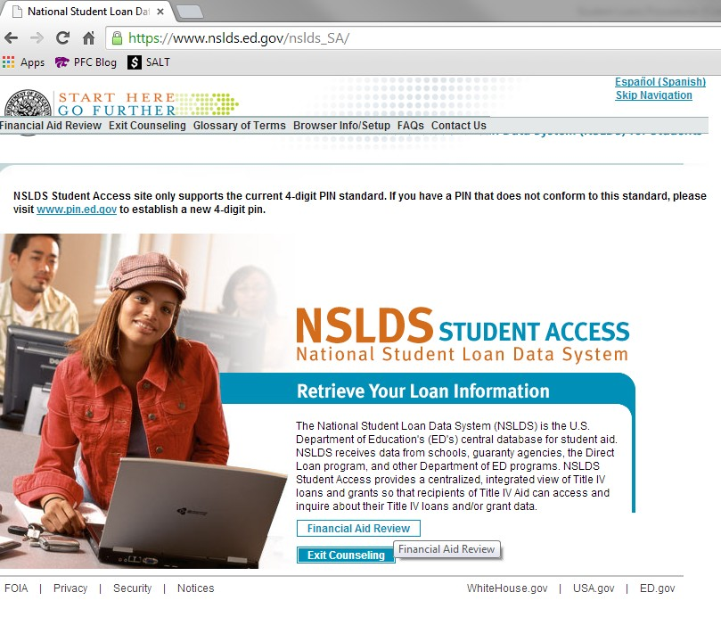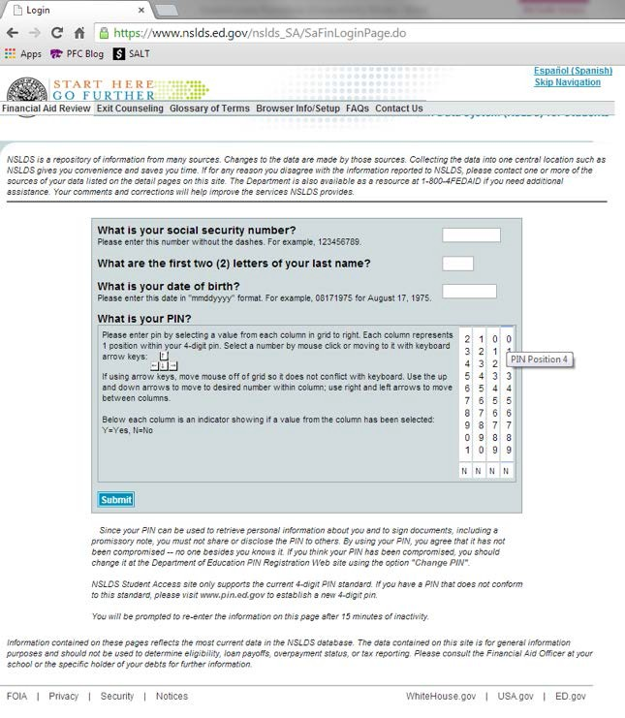

NSLDS Home Page NSLDS Log-In page

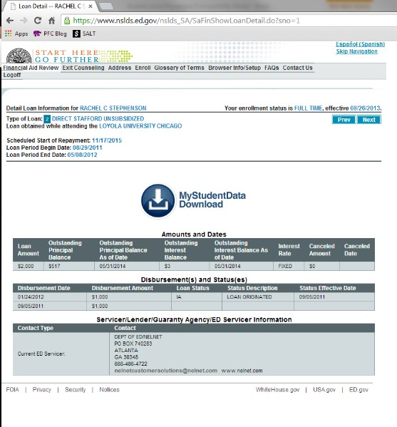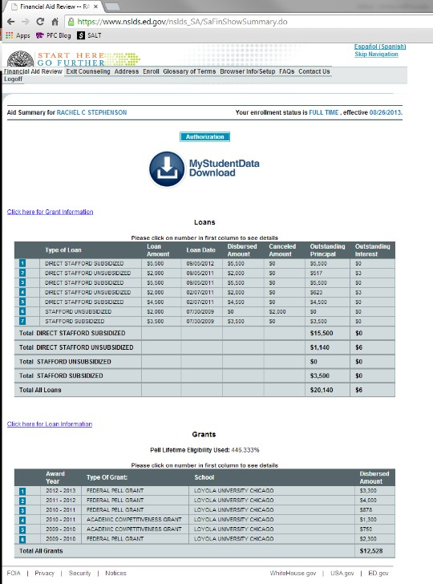 NSLDS Loan Information Page NSLDS

Loan Summary Page

* StudentAid: Original federal government site on financial aid; adopted the features of NSLDS to be a one-stop federal aid site (before and after borrowing).
  + Requires FSA ID to log in
  + <https://studentaid.ed.gov/>
  + Repayment estimator: Shows each repayment plan’s estimated payment requirement (and potential forgiveness amount)
    - Sign in with same information

*<https://studentloans.gov/myDirectLoan/mobile/repayment/repaymentEstimator.action>

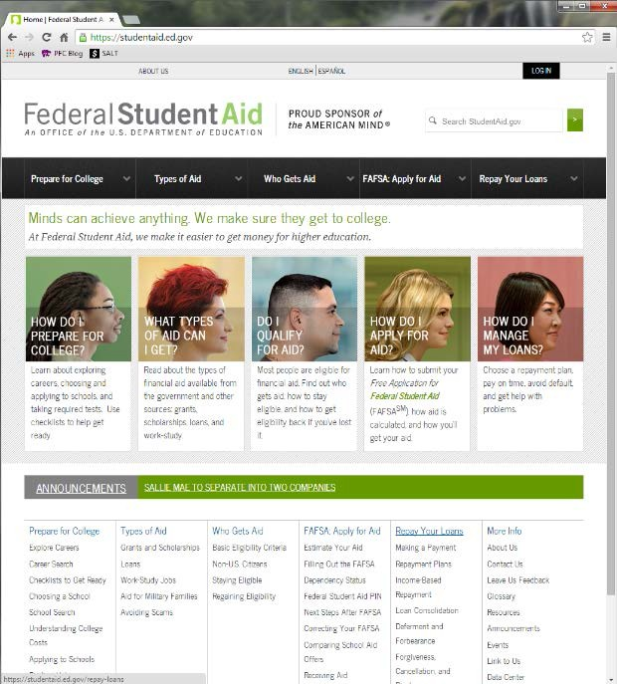 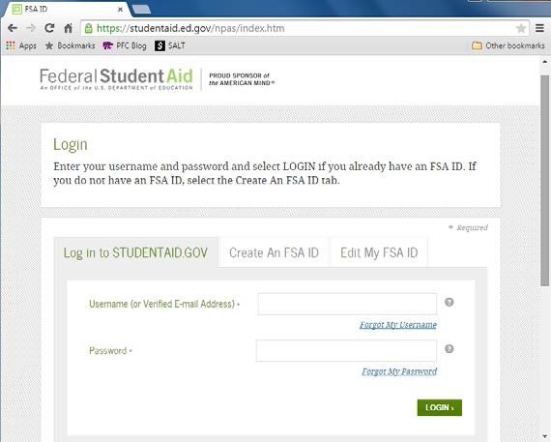

StudentAid Home Page StudentAid Log-In Page

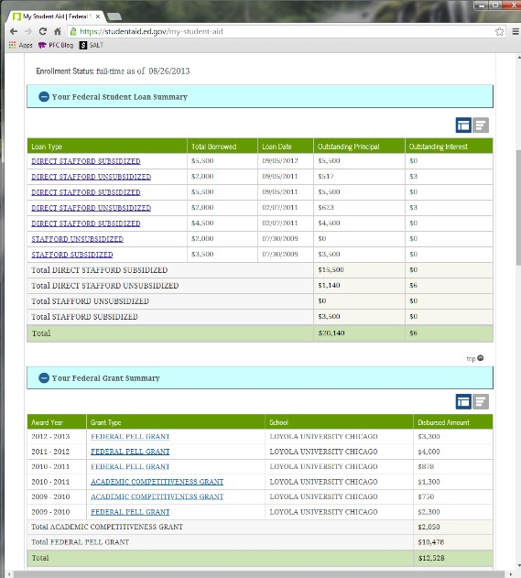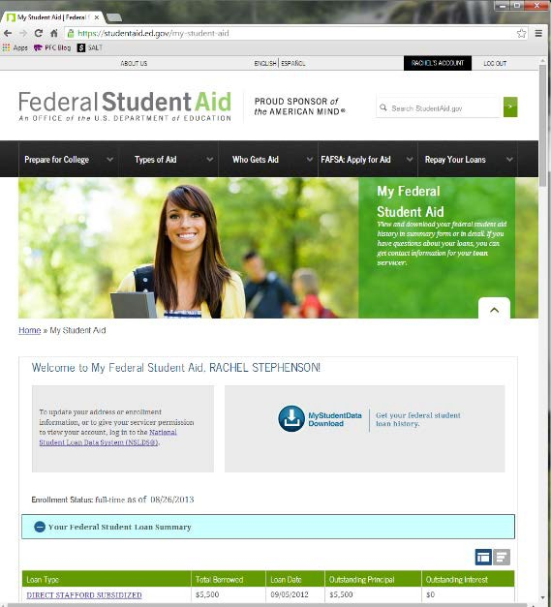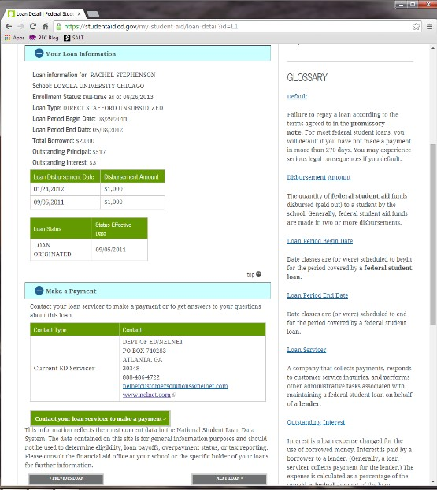

StudentAid Loan Summary Page StudentAid Loan Information Page